Analysis of Clamp Assembly

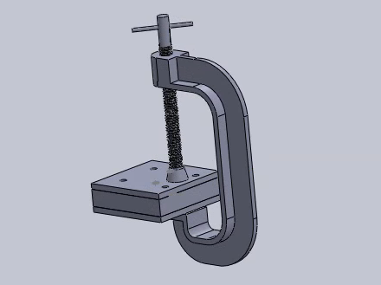

ENGR 3117 Fall 2021

Dr. Laura Riggio

Team 4:

Matthew Newman, Samuel Lee, Zach DeLong

# Introduction

The purpose of this project was to design a c-clamp that has a holding capacity of 4,047 lbf (18000 N), a minimum reach of 4.5 inches, a factor of safety between 1.25 and 2, and to keep the weight as low as possible. The clamp that we decided to create uses a T-beam cross section and is composed of alloy steel. We went through several iterations in order to make the clamp able to hold such a large force. We also performed a bending test on the handle and tested it’s holding capacity on the plates from our bolt project.

# Design Process

## Initial design

The Initial design of our C-clamp was inspired by a C-clamp that we found on Mc-Master Carr [C-Clamp, Steel, Sliding T-Handle, 0"- 8" Opening | McMaster-Carr](https://www.mcmaster.com/5027A16/). It was composed of alloy steel and the T-channel used for the body was based off of measurements that were also found on Mc-Master Carr <https://www.mcmaster.com/beams/shape~t-bar/>. We used the ⅛” thick walls and

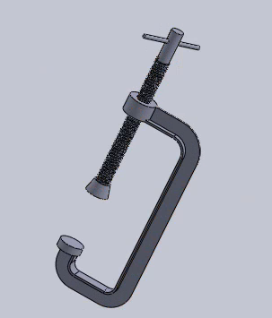

*Initial C-Clamp Design*

We were not able to fully complete the studies performed on this design due to the displacement being too much for solidworks to calculate. We assume this is because this design is far from being capable of holding the 18000 N load applied to it. We were able to perform a test with only a 100 N load and that yielded a maximum stress of 2.581*10^7 so we knew that we had to make some changes in order for this clamp to pass the tests that it needs to.

## Design 2

For our second design we used a larger T-beam for the body of the clamp. This time we used the T-beam with 3/16” thick walls and 1.5” width and height. This time we were able to perform an analysis with the 18000 N force applied and we got a maximum stress of 2.446 *10^9 which is significantly more than the yield stress.

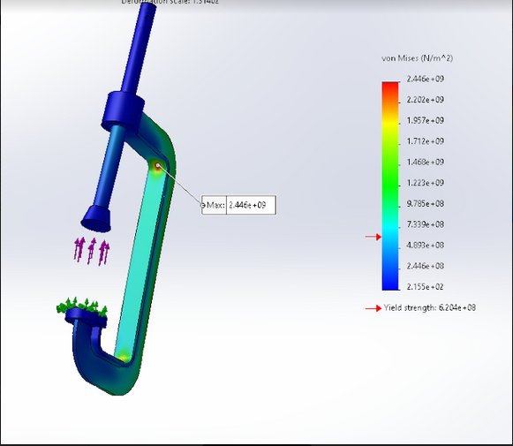

*Design 2 Stress Analysis*

## Design 3

For the third iteration of our clamp we used the ¼” thick T-beam with a width and height of 2”. In order to try to decrease overall dimensions of the clamp the width of the T-beam was cut down to only 1” if we were to produce this design the T-beam that we purchased would have to be machined down a little or an alternative source found. The maximum stress on this design was 8.186*10^8.

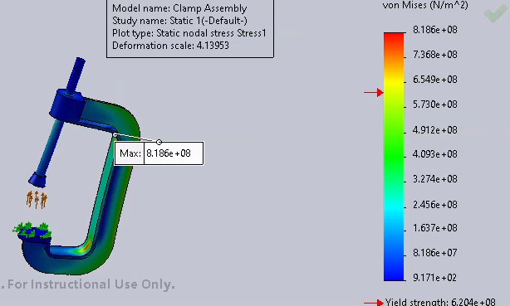

*Design 3 Stress Study*

In this design you will also notice that we changed the shape of the top head on the clamp body. This change doesn’t significantly impact the strength of the clamp, but it does look a little nicer and more put together.

## Design 4

For the fourth design we altered the dimensions of our clamp a little. By increasing the radius of the bend in the T-beam we thought we could decrease the maximum stress. This didn’t have much impact however leading to a maximum stress of 8.132 *10^8 which is only slightly less than that of the previous design.

## Design 5

Test 5 was our first test that succeeded in having a maximum stress that was below the yield stress of the material. For this design we again went up to a larger T-beam. This time we used the beam with the ⅜” thick wall and 4” width and height. 4” is really too big to be used in a clamp of this size however so we would have to machine it down to a 2” width and height. This design is twice as wide and tall and 3 times as thick as our original design.

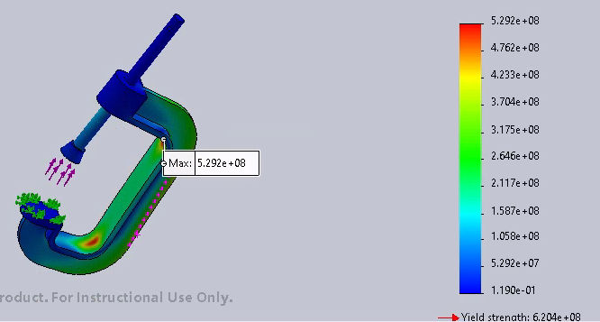

*Design 5 Stress Analysis*

The maximum Stress was 5.292*10^8 which is below the yield strength of the material (3.204*10^8), however that only gives a factor of safety of 1.173 which is slightly below the required factor of safety of 1.25.

## Final Design

For the final design of the clamp we again increased the radius of the bends in the T-beam. This modification reduced the maximum stress to 4.686*10^8 and yielded a safety factor of 1.335, which passes the requirements for the report. Below is the completed analysis of the final design.

### Model Information

| |  | | --- |   Model name: Clamp Assembly  Current Configuration: Default | | | |
| --- | --- | --- | --- | --- |
| Solid Bodies | | | |
| Document Name and Reference | **Treated As** | **Volumetric Properties** | **Document Path/Date Modified** |
| Cut-Extrude1 | **Solid Body** | **Mass:4.44569 kg**  **Volume:0.000577363 m^3**  **Density:7,700 kg/m^3**  **Weight:43.5678 N** | **C:\Users\tuh37181\Desktop\OneDrive - Temple University\Solidworks\homework files\Final project\C clamp base.SLDPRT**  **Dec 2 11:33:02 2021** |
| Cut-Extrude1 | **Solid Body** | **Mass:0.0846814 kg**  **Volume:1.09976e-05 m^3**  **Density:7,700 kg/m^3**  **Weight:0.829877 N** | **C:\Users\tuh37181\Desktop\OneDrive - Temple University\Solidworks\homework files\Final project\Screw Foot.SLDPRT**  **Nov 17 15:04:20 2021** |
| Cut-Extrude1 | **Solid Body** | **Mass:0.608605 kg**  **Volume:7.90396e-05 m^3**  **Density:7,700 kg/m^3**  **Weight:5.96433 N** | **C:\Users\tuh37181\Desktop\OneDrive - Temple University\Solidworks\homework files\Final project\Screw.SLDPRT**  **Nov 17 15:04:20 2021** |

### Material Properties

| Model Reference | Properties | Components |
| --- | --- | --- |
|  | | Name: | Alloy Steel | | --- | --- | | Model type: | Linear Elastic Isotropic | | Default failure criterion: | Max von Mises Stress | | Yield strength: | 6.20422e+08 N/m^2 | | Tensile strength: | 7.23826e+08 N/m^2 | | Elastic modulus: | 2.1e+11 N/m^2 | | Poisson's ratio: | 0.28 | | Mass density: | 7,700 kg/m^3 | | Shear modulus: | 7.9e+10 N/m^2 | | Thermal expansion coefficient: | 1.3e-05 /Kelvin | | SolidBody 1(Cut-Extrude1)(C clamp base-1),  SolidBody 1(Cut-Extrude1)(Screw Assembly-1/Screw Foot-1),  SolidBody 1(Cut-Extrude1)(Screw Assembly-1/Screw-1) |
| Curve Data:N/A | | |

### Loads and Fixtures

| Fixture name | Fixture Image | Fixture Details |
| --- | --- | --- |
| Fixed-1 |  | | Entities: | 1 face(s) | | --- | --- | | Type: | Fixed Geometry | |
| Resultant Forces   | **Components** | **X** | **Y** | **Z** | **Resultant** | | --- | --- | --- | --- | --- | | **Reaction force(N)** | -0.000766039 | -18,000 | -7.15256e-05 | 18,000 | | **Reaction Moment(N.m)** | 0 | 0 | 0 | 0 | | | |

| Load name | Load Image | Load Details |
| --- | --- | --- |
| Force-1 |  | | Entities: | 1 face(s) | | --- | --- | | Type: | Apply normal force | | Value: | 18,000 N | |

### Study Results

| Name | Type | Min | Max |
| --- | --- | --- | --- |
| Stress1 | VON: von Mises Stress | 1.695e+00N/m^2  Node: 36374 | 4.646e+08N/m^2  Node: 30048 |
| Clamp Assembly-Static 1-Stress-Stress1 | | | |

| Name | Type | Min | Max |
| --- | --- | --- | --- |
| Displacement1 | URES: Resultant Displacement | 0.000e+00mm  Node: 145 | 8.356e+00mm  Node: 37409 |
| Clamp Assembly-Static 1-Displacement-Displacement1 | | | |

# 

# Mesh Independence Study

The mesh independence study was performed with three separate mesh levels starting at 5001 nodes and going up to 99944 nodes. At lower mesh quality the simulation was not capable of capturing the maximum stress on the clamp however if we look at the highest quality mesh we see that it isn’t very different from the results we obtained in the initial study so increasing the quality of the mesh beyond that point isn’t going to dramatically change our results.

## Coarse Mesh

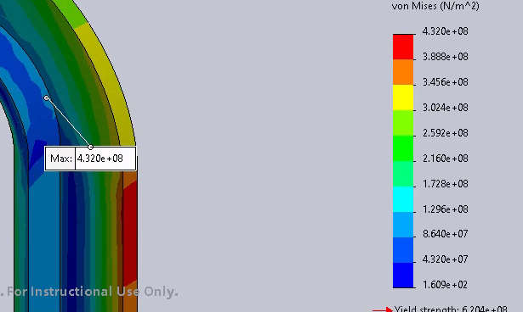

*Coarse Mesh Stress Analysis*

### Mesh Information

Jacobian points for High quality mesh 16 Points

Element Size 16.6081 mm

Tolerance 0.830406 mm

Total Nodes 5001

Total Elements 2422

Maximum Aspect Ratio 14.534

% of elements with Aspect Ratio < 3 88.6

Percentage of elements with Aspect Ratio > 10 0.0826

Percentage of distorted elements 0

## Medium Quality Mesh

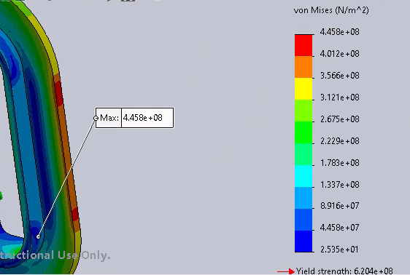

*Medium Quality Mesh Stress Analysis*

### Mesh information

Jacobian points for High quality mesh 16 Points

Element Size 8.74112 mm

Tolerance 0.437056 mm

Mesh Quality High

Total Nodes 15906

Total Elements 8743

Maximum Aspect Ratio 5.1479

% of elements with Aspect Ratio < 3 98.9

Percentage of elements with Aspect Ratio > 10 0

Percentage of distorted elements 0

## High Quality Mesh

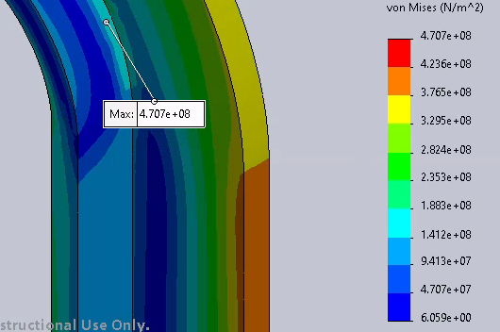

### Mesh information

Jacobian points for High quality mesh 16 Points

Element Size 4.37056 mm

Tolerance 0.218528 mm

Total Nodes 99944

Total Elements 62830

Maximum Aspect Ratio 4.3152

% of elements with Aspect Ratio < 3 99.9

Percentage of elements with Aspect Ratio > 10 0

Percentage of distorted elements 0

# 

# Screw

## Buckling Analysis

The screw buckling test was performed with fixed and free end conditions, with the fixed portion of the screw being placed 5.06” from the base of the foot. This distance was chosen because it is the same position that the screw was in from the clamp solid body test. From buckling analysis, the Critical Buckling Load was found to be 183400 lbs, leading to a critical buckling stress of 415132 psi. This critical buckling stress is greater than the screw’s material yield stress, which is 89984.6 psi, resulting in the conclusion that the screw will yield before it buckles.

*Screw Buckling Analysis*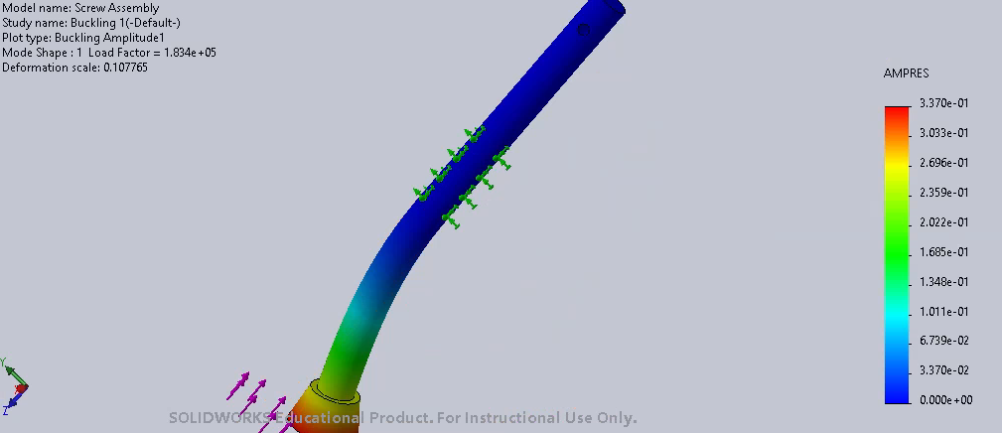

Since this buckling analysis was tailored to this specific process, a validation was performed to ensure accurate results. A basic buckling analysis was done, with the fixed end being the bottom of the screw, as seen in the image below:

*Basic Buckling Analysis of Screw*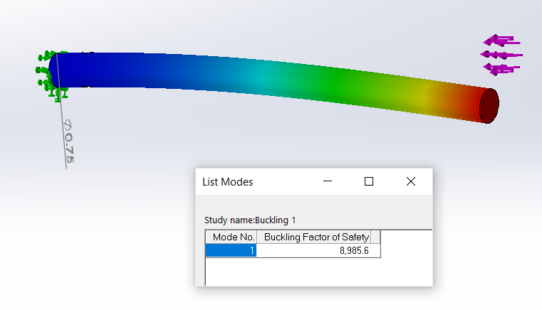

The Critical Buckling Load was found to be 8985.6 lbs, which will be confirmed with classical equations seen on the next page.

The following equations were used to validate the Buckling Analysis of the screw being observed. Below are the classical calculations for the Critical Buckling Load, Pcr :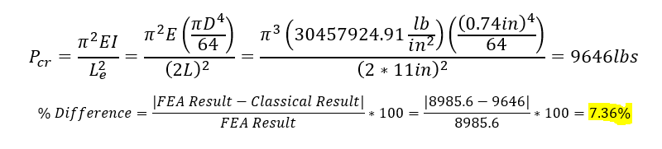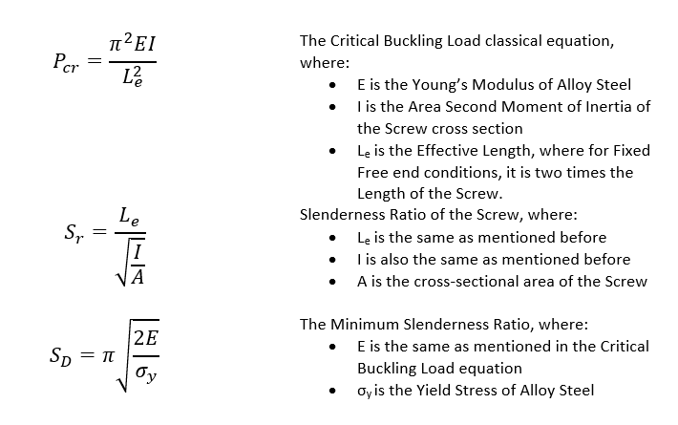

The FEA and Classical results differ by a difference of 7.36%, which is acceptable. In order to determine whether or not elastic buckling is valid for the Fixed Free end conditions of this screw, the Slenderness Ratio of the column will be observed:  
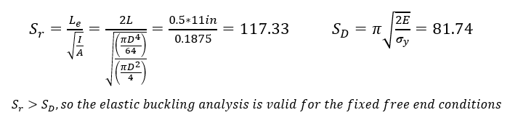

## Shear Stress Due to Torsion

# The following Equation was used to calculate the shear stress in the Screw which is due to Torsion, where the Shear Stress was found to be 480psi:

# Compared to the compressive stress in the buckling analysis, the shear stress is very small and can almost be negligible. This portion of the C Clamp will not be in any danger of failure since the torque required for the screw handle is not very high.

## Bearing Stress in Thread

The following equation was used to calculate the Bearing Stress in the thread of the screw, which was found to be -1406 psi:

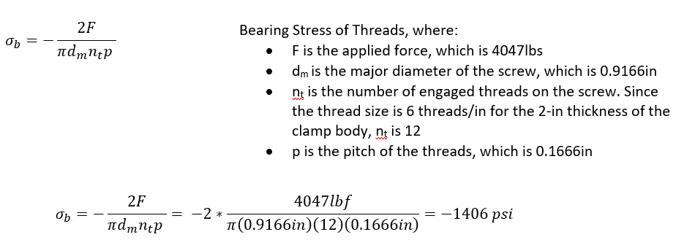Again, this bearing stress is also relatively small compared to the other stresses present in the screw, which are in the magnitudes of tens of thousand psi, and does not pose as much of an issue as other observed stresses. The bearing stress is negative because it is compressive on the threads.

## Bending Stress at Root of Thread

The following equation was used to calculate the Bending stress at the Root of the Thread in the Screw, which was found to be 5155 psi:

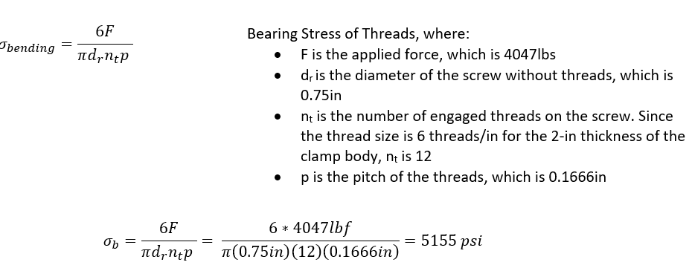

This is a more significant stress due to its relatively high magnitude. However, as mentioned in the other stresses, the magnitude of this stress does not pose a huge issue for the model.

The final model for the Screw assembly is shown below:

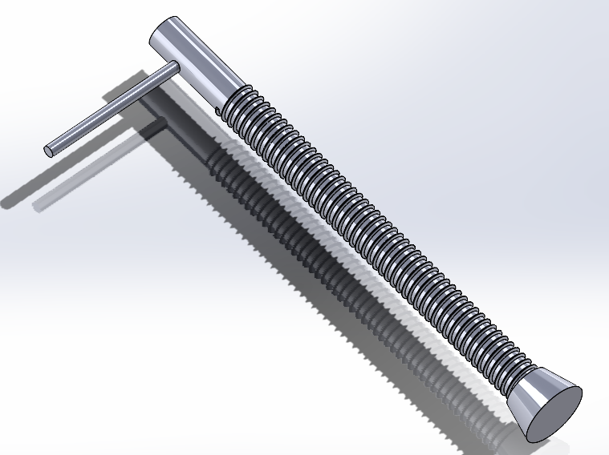

# Screw Handle

**Torque required to achieve the clamping force.**

The equation to determine the torque required to achieve the clamping force comes from chapter 8 of “Shigley’s Mechanical Engineering Design” and is as follows:



In order to utilize this equation, the values of force and thread-width are required, they are shown in the diagram below as “F” and “l”, respectively:

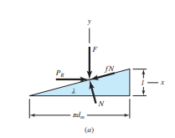

The force used in this equation is the value of holding capacity given in the project instructions (4047 lbf). The value of “l” was calculated from the equation “l” = .3707P that depends on thread pitch “P”, which can be found from the diagram shown below:

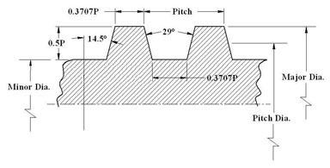

This diagram follows the standards specified by American National Standard ASME/ANSI B1.5. The value used for pitch is a sixth of an inch as 3/4”- 6 threads have six threads per inch, and are the same threads utilized by the c- clamp chosen from McMaster-Carr. “l” is then found:

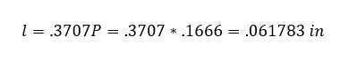

Torque required to achieve the clamping force is calculated:

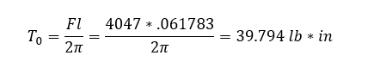

**Force applied to the handle to generate the required torque**

Torque is determined by force and distance so in order to determine the force applied to the handle to generate the required torque we derive that equation to solve for force. The handle is four inches long and the point of force is set at the end of the handle. The force is then calculated:



When applying the 9.9485 lb force needed to generate the torque, the following stress distribution is produced in the assembly analysis below: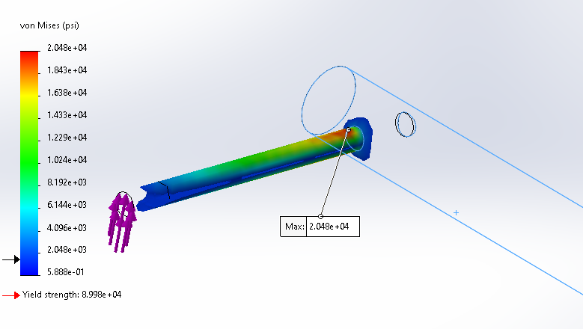

The Max Stress due to bending is less than the Yield stress by more than 400%, deeming that the designed handle is very safe to use. This analysis was done by treating the assembly as a Solid Body. To support the Solid Body analysis, the handle will be analyzed as a beam: the end at the far left will be modeled inside the screw and will be fixed; the force is applied upwards on the right end, seen below: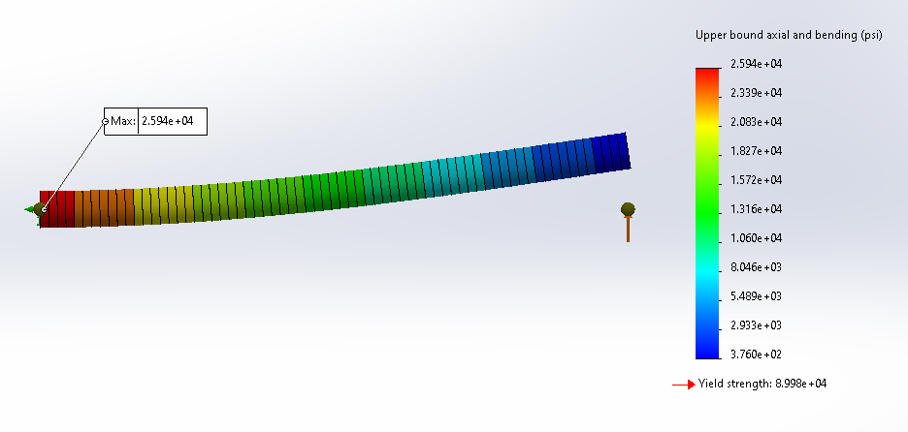

The difference between the Solid Body and Beam stresses is 23.5%. This is primarily due to the fact that the max stress in the Solid Body analysis is closer to the applied force. This closer location creates a smaller moment than the beam analysis, where the entire length of the screw handle increases the moment. Regardless, both tests show that the screw handle is a good and safe design that will not yield.

Body

## Stresses in the Curved Portion of the Body

Since the region of highest stress is the inner portion of the C clamp cross section, the stresses of the inner, or concave portion of the C Clamp’s body will be observed based on the sketch:

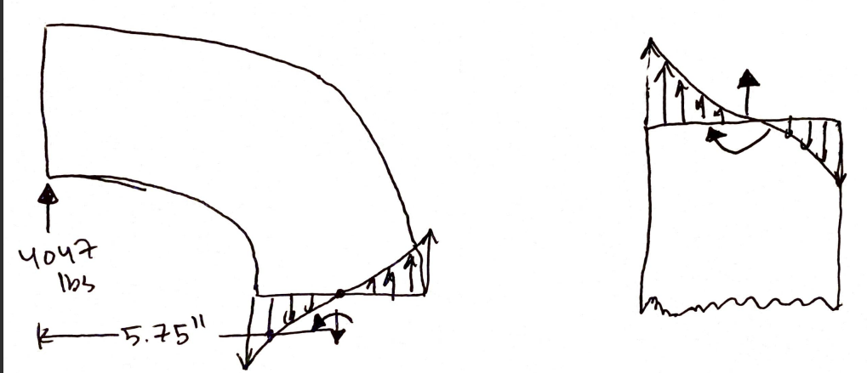

|  | The image on the left provides a description of the T beam cross section and the equations needed to calculate the centroid and neutral axes, where:    These equations led to the development of the Nominal and Shear Stresses in the Curved and Straight Portions of the Clamp’s body, where: |
| --- | --- |

The values for the eccentricity, centroidal and neutral axes are listed below:

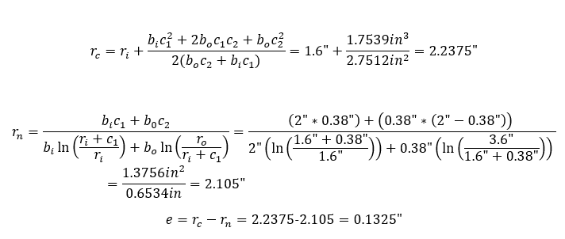

This leads to a stress on the inner portion of the curved beam of:

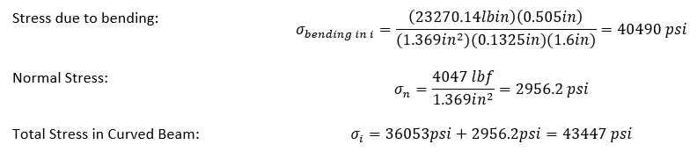

## Stresses in the Straight Portion of the Body

Since the Straight Portion of the body can be viewed as a straight beam that is being bent, the shear stress will be 0 since there is no shear stress acting on the beam. However, the normal and bending stresses are as follows:

The stress in the curved beam is higher than the stress in the straight portion which is plausible, since the curved beam has a stress concentration at its curve.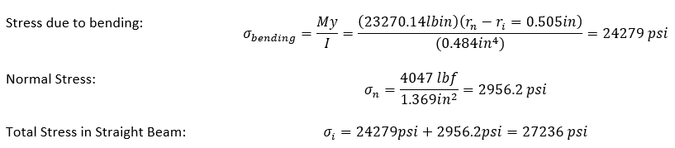

# Bolted Plate Test

The 10000 N force from the bolt project is significantly less than the 18000 N force that the clamp was able to hold during the final design analysis and we see from the analysis that this is in fact the case. The maximum stress inside this system is 1.57*10^8, however that is inside of the plates not the clamp. The plates might deform under this load but the stress on the clamp at it’s weak points is only around 4.17*10^3 which is much less than the yield stress of alloy steel.

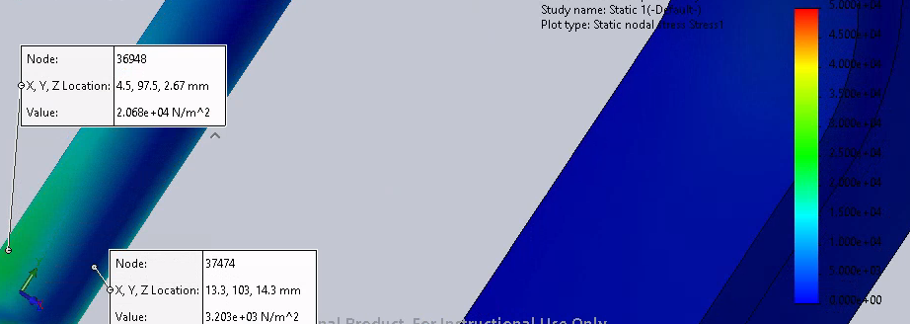

*Yield Stress Along the Screw Handle*

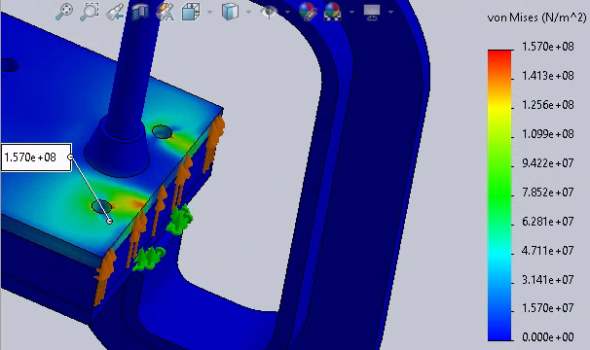

*Maximum Stress In The Plates*

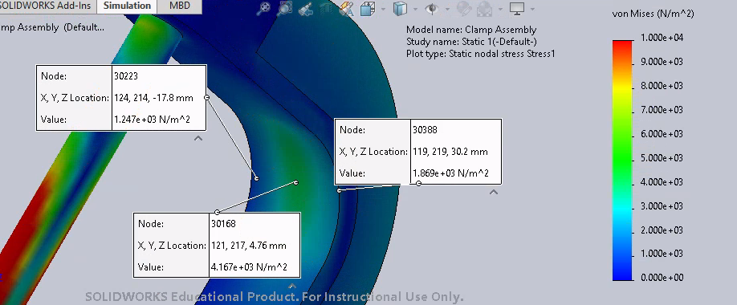

*Stress On Clamp Base*

## Conclusion

The clamp that we designed took many iterations in order to withstand the required load. We underestimated how strong the clamp would have to be and our initial design was far from capable of holding up, but after several redesigns we were able to create a clamp that could withstand a 4047 lbf with a factor of safety of over 1.25 and using commonly available components.

When comparing the C clamp analysis to the Bolt Analysis, the C clamp produced a maximum stress of 157 MPa while the Bolt Analysis produced a maximum stress of 226.9 MPa. Since the stress distribution within the plates is less for the C clamp, the C clamp is preferred over the Bolt method. However, based on the C clamp that was modeled for this design, the cost of the C clamp is about $85, while four of the bolts in the bolt analysis is about $10. While the C clamp creates a better stress distribution than the bolts, the C clamp is also much more expensive. Even with the higher price, failure of materials can create serious issues that must be avoided, so the C clamp is still deemed as the more desirable method of holding the plates together.